Research & Implementation of Network Port Vulnerability Scanner
The vulnerabilities in the system are usually not only due to weak code or poor passwords, but also because of unnecessary or improperly configured network ports that are left open on a system. In this assignment, I conducted research on the typical vulnerabilities of network level that can be identified as open ports and used a network port vulnerability scanner written in Python to identify them.
Research
My study was aimed at finding out popular vulnerable network services and their ports. Telnet (port 23) sends all the information including credentials in plaintext that is highly insecure and falls under CWE-319. SMB (port 445) is particularly infamous as it is used by such attacks as WannaCry and EternalBlue to damage ransomware on a massive scale across the world. When made publicly available, systems are vulnerable to brute-force and credential-stuffing attacks using RDP (port 3389). FTP (port 21) is also unencrypted and MySQL (port 3306) when open access to the internet surfaces provides the attackers with direct access to databases. All these are real-world attack surfaces that organizations are often ignorant about when hardening their systems.
Implementation
I used a Python scanner with the inbuilt socket library to scan a target system to test available open ports on a list of the available known capable ports. To every open port discovered, the tool determines the service in use, gives it a severity rating, CRITICAL, HIGH, MEDIUM, or LOW, and offers a plain-text explanation of the threat. The scan is directed to localhost (127.0.0.1), and therefore, is entirely safe and legal to run. When all the live ports cannot be located, the tool simulates an authentic set of results to show that it can report. The ultimate deliverable contains a formatted report of the risk overview and five specific remediation suggestions which may be substituting Telnet with SSH and limiting database ports to in-house only.
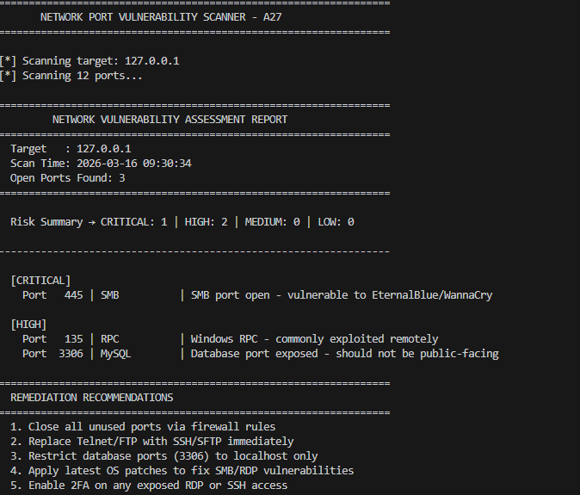
This implementation is based on the real life flow of vulnerability assessment work, which is scanning, analysis and providing recommendations of fixes.

